 | Innovation Report Cover Page & Innovation Description Form  Human Powered Vehicle Challenge  Competition Location: Digital  Competition Date: 3rd April 2021
This required document for all teams is to be incorporated into your Innovation Report.
Please Observe Your Due Dates; see the ASME HPVC website and rules for due dates.

University name: Grand Canyon University

Vehicle number: 11

Innovation title: Fabric Fairing

Innovation summary (Up to 150 words): The innovation that was used in the human-powered vehicle design was the fairing, which covers the front and top of the vehicle. The design of the vehicle's fairing is an innovation because it is made completely of fabric. It attaches directly to certain members of the vehicle frame while wrapping around the rest of the frame, giving the fairing its aerodynamic shape. Clear polyvinyl will be used for the majority of the fairing while canvas will be used along the edges of the fairing to provide stronger, more reliable points of attachment between the fairing and the frame.

2021 Human Power Vehicle Challenge Innovation Report

College of Science, Engineering, and Technology Grand Canyon University
GCU ASME Club
Team Captain: Thien Nguyen
Team Lead: Alyssa Shuman, Danielle Nguyen, Emma Johnson, Kristeen Huynh, Roberto Casas
General Members: Adriana Cisneros, Andrew Hix, Cassandra Westwood, Glenaldo Pangestu, Kaeleen Boggs, Roxanna Mendoza, Tung Nguyen
Club Advisors: M.S. Li Tan, Dr. Michael De Gregorio, Dr. Kevin Williams
03/03/2021

Table of Contents
Table of Contents  - Abstract  - Innovation – Fairing  - Innovation Multiplier  - Design  - Need  - Advancing the Art of HPVs  - Technology and Concept Feasibility Study  - Concept Evaluation  - Functionality Evaluation  - Benefit Study  - Unanticipated Benefits  - Learnings  - Failures  - Learning From Failure  - Negative Aspects of the Design  - Conclusion  - Vehicle Designs  - Ergonomics  - Research and Assumptions  - Ideal Pilot  - Critical Dimensions of the Vehicle  - Potential Power Output  - Frame  - Design  - Simulation and Analysis  - Fabrication Process, Challenges, and Solutions  - Drivetrain  - Chainring  - Cassette  - Shifter and Other Components  - Finance  - Funding Resources  - Finance Management  - Challenges and Solutions  References | 1  2  2-10  2  2-3  2  3  3  4-9  4  8  9  9-10  9  10  10  10  10-18  10-11  11  11  11  11  11-16  11  13  15  16-17  16  17  17  17-18  17  18  18  19

    - Abstract
The GCU ASME team is designing, fabricating, and competing in the 2021 ASME Human Powered Vehicle Challenge. The designed vehicle is a tadpole recumbent tricycle with a braking system installed on the two front wheels. Front and half fairing is also implemented to increase the aerodynamic-flow around the vehicle to either reduce the input power or obtain a higher speed. The first year of design and fabrication has brought multiple challenges to team members such as limited budget, time, and pandemic restrictions. Facing such challenges, the team is determined to complete the project using different innovation ideas and one of which is to simplify the fabrication method for the designed fairing. The fairing materials consist of canvas fabric, clear plastic, and round steel tubes. The fabrication process requires metal cutting, MIG welding, and sewing skills. The fairing budget stays under $200 and fabrication time allows team members to complete the project at the end of April 2021. All of the listed conditions can be achieved by current team members and thus, the success of the overall project also increases.
    - Innovation – Fairing
2.1. Innovation Multiplier
Many human-powered vehicles utilize a full-fairing design, mainly for their highly effective aerodynamic qualities. Furthermore, these full fairings are typically fabricated by applying alternating layers of fiberglass cloth and epoxy over some sort of foam mold that was custom designed and fabricated for the shape of the vehicle; this fabrication process is very intensive, practically takes forever to complete, and can also be quite expensive [1] [2]. With the lack of proper funding and resources to be able to tackle such a hefty endeavor, it became necessary to find a more feasible method that would still provide an acceptable fairing for the designed human-powered vehicle. The innovative solution that was agreed upon was to design and fabricate a fairing fully made of fabric. While fabric fairings are fairly common, the particular design that was used was innovative concerning its role in the project. It utilized two different materials, clear polyvinyl and heavyweight canvas, that were joined together to create the overall fairing for the vehicle. This fabric was then stretched over the frame of the vehicle, giving the fairing its shape. And that's it. Sure, it took time to figure out the yardage of fabric and the shape and size of the pieces, as well as to sew everything together. But compared to the material cost, fabrication process, and necessary amount of time to construct a fairing using the previously mentioned more traditional techniques, creating a fabric fairing was a way better option for this project's success.
2.2. Design
2.2.1. Need
With low funds for the project and a lack of other resources (including time, people, and materials), it became necessary — for the sake of the project — to find a way to create a fairing for the vehicle that would offer all the same benefits that a typically fabricated fairing would, but for far less money and in a much shorter amount of time. Some things had to be sacrificed to make this impossible task one that was possible. So, the aerodynamic excellence and snazzy, professional-looking aesthetics of a fiberglass full fairing had to be ditched — for the sake of the project. This, however, did not result in a drastically inferior design. Being forced down this project route resulted in rather innovative design decisions, at least with respect to the scope of this project, and the fairing that resulted still offered excellent aerodynamic performance, and it also was aesthetic in its own right. The innovative design addressed the need to complete the project on a much lower budget with limited resources and with limited time, and to do so without completely sacrificing a couple of the key components that make a fairing important and fun to design.
    - Advancing the Art of HPVs
Utilizing the design of a full fabric fairing had multiple benefits. For starters, the clear polyvinyl allowed for a front-and-top fairing shape to be achieved while providing a large window for the driver to see, and the heavyweight canvas helped to anchor the clear polyvinyl to the frame of the vehicle. Also, because the fabric fairing was wrapped around certain members of the vehicle's frame, it was able to create and maintain a nice aerodynamic shape while still providing plenty of open spaces to let in fresh air so the driver wouldn't overheat and malfunction (as drivers tend to do when they're wrapped in plastic on a hot, sunny day). The canvas areas of the fairing also created a space for snaps to be used so that the fabric could be wrapped around the vehicle's frame and snapped in place. Likewise, if ever necessary, the fairing could be completely removed quickly and simply, whether for washing, or when the vehicle needs to be stored away, or if future students want to utilize the same vehicle frame but improve on the fairing because everyone knows that there's always room for improvement. Furthermore, a full fabric fairing costed way less to produce than if the fairing were made using the more common fabrication methods (as previously discussed). It also saved a lot of time and made it possible to complete the project within the project timeline. Most importantly, though, the chosen design for the fabric fairing was based on its aerodynamic qualities and performance. The design decision that was made was for a fairing that covers the front and top of the vehicle. This chosen fairing design outdid most other options for the shape of the fairing, the only exception being a full fairing, which would have covered the entire frame. The fabric fairing made it possible to design and manufacture the aerodynamically next-best fairing shape option.
    - Technology and Concept Feasibility Study
When camping, a tent tends to be the go-to shelter, and typically involves some fabric being stretched over some sort of frame. The tension that exists as a result of the fabric pieces and the 3-dimensional form created by the structural members is what allows the tent to hold its shape. In the same way, the designed fabric fairing will be able to hold an aerodynamic form around the vehicle. This goes to show that the "technology" behind the fabric fairing is nothing new, but its application in the scope of the project is still innovative in that it provides fully functional vehicle fairing by utilizing techniques that are common in other applications. And while this may be the case, applying these techniques to this specific project does not make this specific application unfeasible. It is rather attainable: the different fabrics will be measured and cut to the appropriate dimensions and sewn together; snaps will be inserted along the edges of the fairing that will wrap around certain members of the vehicle's frame; and, to finish off the vehicle, the fabric fairing will be stretched over the frame and snapped into place. The result: an innovative idea consisting of a simple design with simple methods of execution.
  - Concept Evaluation
    - Functionality Evaluation
The intended purpose of this innovation was to provide a fairing that would enhance the aerodynamics of the vehicle as much as possible while dealing with low project funding and resources. There were many different types of fairing shapes commonly used in the human-powered-vehicle design. To analyze which shape would be the most aerodynamic, five different fairing shapes were modeled in SolidWorks and compared to each other and to the case where there is no fairing (Figure 1).
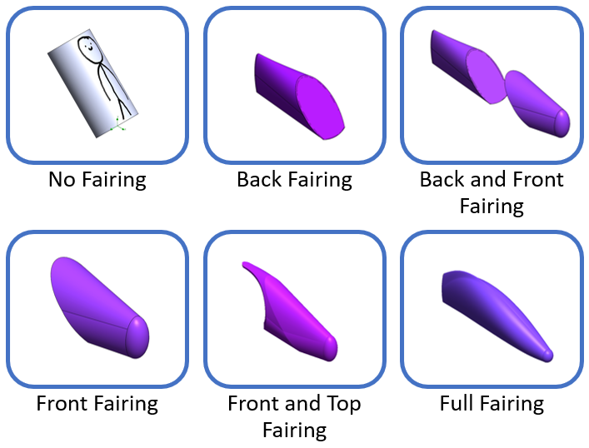
Figure 1: SolidWorks models of fairing shape options
For the sake of simplicity, the no-fairing case merely consists of a person represented by a cylinder, and the frame of the vehicle was completely omitted from all of the simulations. Neither a detailed model of a person nor the frame of the vehicle was needed in the simulations because the simulations were solely looking at the comparison of aerodynamic qualities of the fairings themselves; even without all the nitty-gritty details, you still get the gist of which fairing shape is the most aerodynamic from the simulation.
After the different fairing options were modeled in SolidWorks, a flow simulation was separately run on each model to determine what the drag force was for each fairing shape (Figure 2).

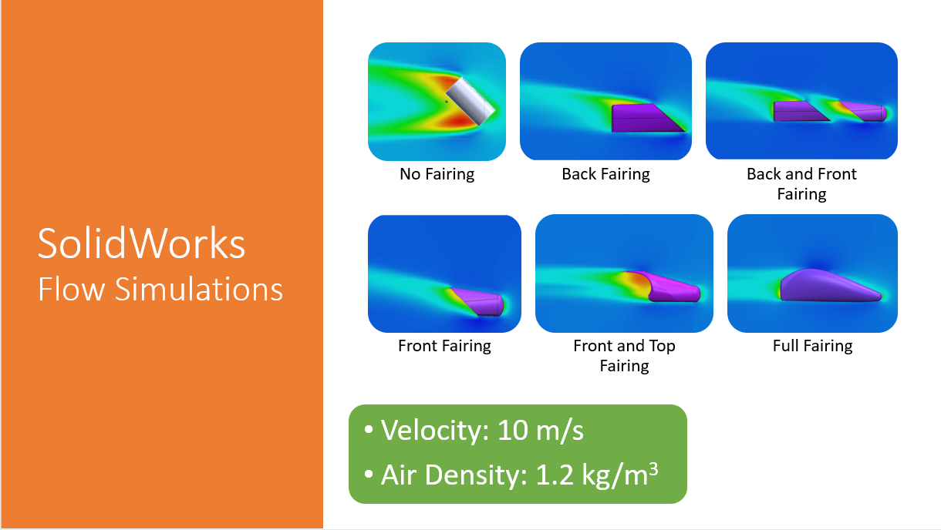
Figure 2: SolidWorks flow simulation parameters and visual results
The velocity was set to 10 m/s for each simulation, a value that was based on the average velocities between recumbent trikes built for speed and those built for around-town use [3]. The air density was set to 1.2 kg/m³, a value based on the average density of air at sea level [4]. As a side note, the simulation for the back fairing probably wasn't the most accurate because, in real life, there would be a person sitting in front of the fairing, creating a more aerodynamic shape, whereas, in the simulation, all the air is just colliding head-on with the flat face of the front of that fairing shape. But, as previously stated about this SolidWorks simulation and its results: you get the gist. The resulting drag forces from the simulations are listed below in Figure 3 with their respective fairing shapes, as well as the corresponding measured surface areas.

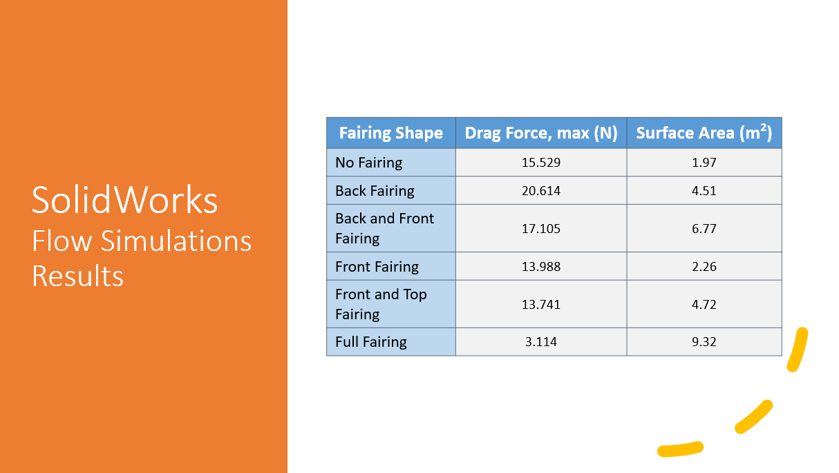
Figure 3: SolidWorks flow simulation results for drag force and measured surface areas for each fairing shape
For each fairing shape, their particular drag forces and surface areas, as measured in SolidWorks, were used to determine the drag coefficient for each fairing, which help to properly gauge and compare the aerodynamic capabilities for each fairing shape. The drag force was determined by using the following equation:
$$C_{d}=\frac{F}{ρv^{2}A}$$
where $C_{d}$ is the drag coefficient, $F$ is the drag force in $N$, $ρ$ is the air density in $kg/m^{3}$, $v$ is the wind speed (velocity) in $m/s$, and $A$ is the reference area (in this case, the surface area of the fairing) in $m^{2}$ [5].
Once the drag coefficients were determined for each fairing design option, their values were graphed against the corresponding values for surface area for each fairing (Figure 4).
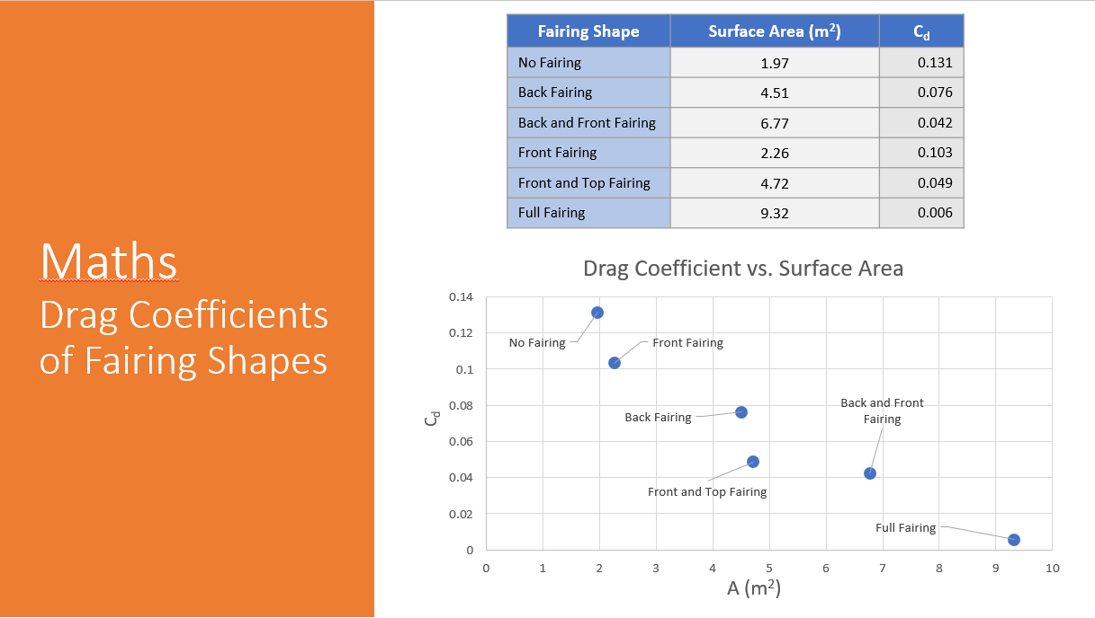
Figure 4: Relationship between drag coefficient and surface area for each fairing shape
Visually representing these values helped to show the relationship between the surface area and the aerodynamic qualities of a fairing. It can be seen in Figure 4 that they are inversely proportional: a lower drag coefficient (which means better aerodynamic performance) corresponds to higher values of surface area. This, therefore, proves that the use of fairing, in general, greatly enhances the vehicle's aerodynamic qualities.
While the results from this simulation were pretty good, they were entirely substantial on their own in guiding the decision on which fairing design option would have the best performance, because drag force also has a relationship to how much power is required by the driver to get the vehicle moving. The standard equation for power was used:
$$P=Fv$$
where $P$ is power in watts, $F$ is the force (the drag force, in this case) in newtons, and $v$ is the velocity in $m/s$. Once the necessary power was determined for each fairing design option, the different values were graphed against the corresponding values for the drag coefficient of each fairing (Figure 5).
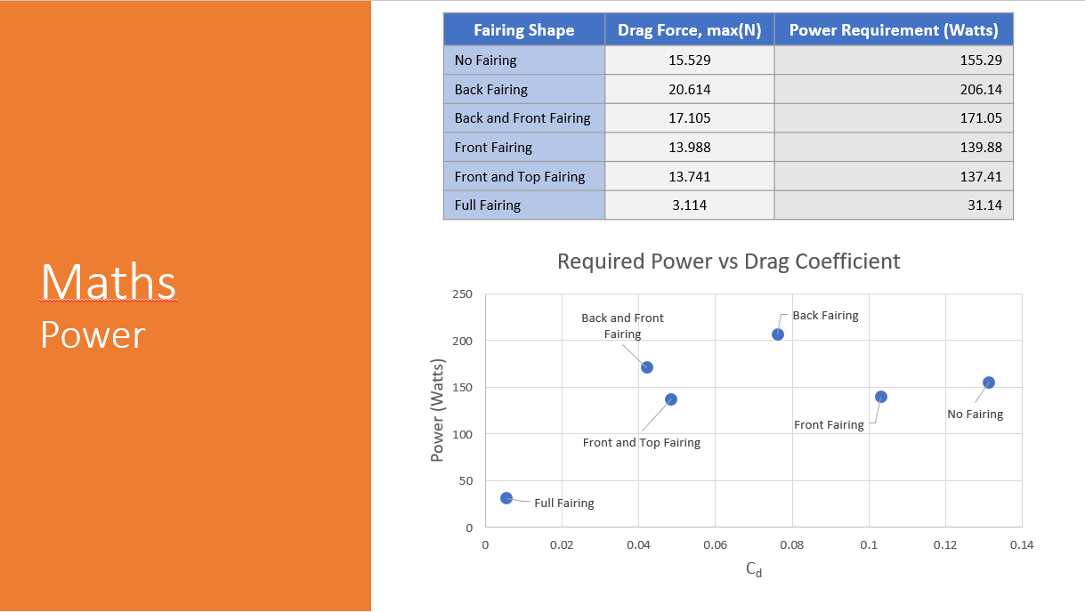
Figure 5: Relationship between drag coefficient and power for each fairing shape
Visually representing these values helped to show the relationship between the aerodynamic qualities of a fairing and the required power from the driver. It can be seen in Figure 5 that they are, generally, directly proportional: less power is required from the driver for fairings with lower drag coefficients. As previously mentioned, the simulation for the back-fairing shape might not have been entirely accurate (for reasons already discussed), so its data point on the graph may be more of an outlier than anything. But as stated a couple of times before, you get the gist.
With the necessary calculations and comparisons completed, the resulting data was then used to determine the best fairing shape for this project. The criteria for determining the best option for the fairing design are shown below in Figure 6, and the resulting outcome is shown in the following figure (Figure 7) as a decision matrix.

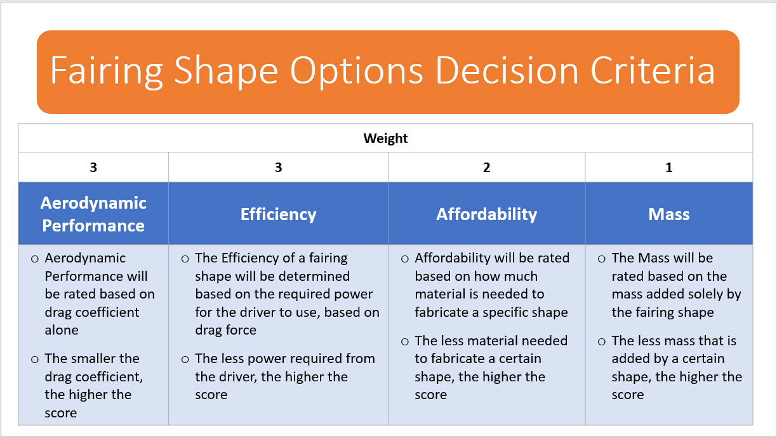
Figure 6: Decision criteria for fairing shape options
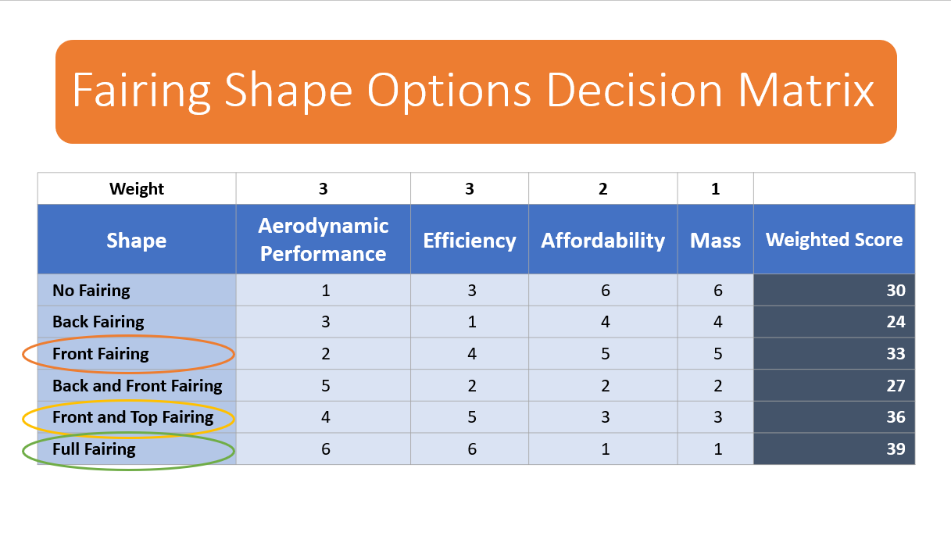
Figure 7: Decision matrix for fairing design options
Based on the simulation results as well as the resulting data from calculations and comparisons, the most optimal fairing design would be a full fairing. However, for the scope of the project (considering a lack of the proper resources and time), the second-best option was settled on, for the sake of the project, and the sake of the team's sanity. The front-and-top fairing design was still highly aerodynamic and efficient despite its lower cost compared to the full fairing.
    - Benefit Study
A major benefit from this innovation was that it took less time and money to fabricate a nearly full fairing than it would take to fabricate a full fairing using the more typical methods and materials that have been previously discussed. This more typical approach to building a full fairing (the best type of fairing, according to the aforementioned simulation data) would take many months of build-time and upwards of a thousand dollars, based on the necessary materials and methods outlined by different recumbent bike builders and their full-fairing build projects [6]. However, after determining the amount of fabric necessary to create a front-and-top fairing shape, as well as the necessary hardware, the total cost for this innovative design choice was less than half a thousand dollars [7] [8]. It also took less build-time. Another benefit from this innovation was the fact that, even though it cost less to make overall, it still offered satisfactory aerodynamic qualities and aesthetics, as formerly mentioned and proven based on the SolidWorks simulation data.
    - Unanticipated Benefits
In all honesty, there were not many real unanticipated benefits from this innovation. The innovation was thought of specifically to address the problems that the team was facing when it was realized that the project funding was cut short and some members had to prioritize their schoolwork over the completion of the project. The innovation was thought of to meet specific needs, and that it did. Outside of those needs, however, it offered little other than some good times in the engineering shops designing and putting things together.
  - Learnings
    - Failures
At the time of completing this report, the fairing has not been fully constructed. But that does not mean that failings and learnings were not obtained along the road of decision-making and design. For instance, the original plan was to design and build a full fairing using the typical methods of layering fiberglass cloth and epoxy resin to build a sturdy, sleek, and stylishly snazzy shell for the vehicle. This design idea, however, failed in the scope of the project because of inadequate time and funding, which was revealed at a later-than-convenient time in the project timeline. So, this design failed the project in its cost and necessary completion-time. Another thing that probably didn't work as well as it should have was the SolidWorks simulation. As mentioned before, the model of the back fairing might not have been as accurate as the other models used in the simulation because it did not have a "person" placed in front of it in the simulation, which would have better replicated real-life situations. Having a person modeled at the front of this fairing shape would have made the shape more aerodynamic; but, in the simulation, all of the simulated air was rushing right into the flat surface at the front of that particular fairing shape, creating a rather large amount of drag at the front of this fairing design. Overall, it can also be argued that all of the simulation methods were not done in an exemplary manner. But, to provide some data can be worked with to offer a general depiction of the relationship between drag forces, power, and fairing shape to help make a well-rounded decision on which fairing shape would be most beneficial to the project, the SolidWorks simulations were satisfactory if nothing. And the great thing about being satisfactory is that things meet whatever requirements that needed to be met but still leave room for improvement.

    - Learning From Failure
The most obvious success that came out of a failure in this project was the innovative fairing design itself. When the original design failed in the sense that it was too intensive and too expensive for the scope of the project, the project wasn't canceled. If anything could be drawn from this project, it's that failures should not lead to cancellations, but innovations. And that's exactly what happened. Rather than scrapping the project until the next academic year rolls around, it was decided to figure out the things that were feasible with the resources that were available in the time that was left, to roll up our sleeves, and get to work on something new. And in coming up with a creative solution to provide a design plan for the original one that failed us, we learned that failures and shortcomings should not be an excuse to wait for the opportune time. This failure taught us that failures can be opportunities in and of themselves to think outside the box and solve a problem differently.
    - Negative Aspects of the Design
Sure, the innovative design helped to overcome a failure in the project and led to creative problem-solving and a spirit of perseverance in the face of adversity. But the designed innovation was not without some negative aspects. For one, while the design provided a way to construct a fairing in a shorter amount of time, its construction process would still be tedious, as it involves sewing and inserting the hardware into the fabric pieces. It also greatly depends on the shape of the frame of the vehicle itself, so it becomes difficult to simultaneously construct the fairing while the vehicle's frame is also being constructed. However, for the most part, the innovative design helped to take care of and address the main issues that the team faced once the project was underway.
  - Conclusion
In the end, the innovative fairing design provided the means to complete the human-powered vehicle with limited resources and time. It was an innovation in the sense that it was a creative way to provide a complete fairing with aerodynamic qualities despite not having the necessary means to build a full fairing the more conventional way.
- Vehicle Designs
The Vehicle Design section discusses critical designs of the GCU 2021 vehicle. Team members were not able to participate in the Critical Design Review and thus, the team needs to report design elements that affected the overall project, including the reason for the team's innovation fairing fabrication ideas. It is understood this section would not be counted towards the competition scoring system; however, any feedback from the judges on this section will be greatly appreciated. The feedback will be utilized for future competitions.
  - Ergonomics
To begin the development process for this vehicle the functional limits of the human body had to be determined in several critical areas to ensure the overall functional support and function of the vehicle. The dimensional averages of the human body were determined which led to the development of the dimensional specifications of the vehicle. The potential power output of the human rider was also considered.
    - Research and Assumptions
Through the course of researching the dimensional limitations of the human rider, national averages were used for estimations and the determine the required strength of materials to be used in construction. The averages used were determined as national averages in the United States. The average height and weight of an American male were found to be 5 ft. and 10 in. (178 cm) and 197 lbs. (89 kg) respectively. The average height and weight of an American female were 5 ft. and 4.5 in. (164 cm) and 170 lbs. (77 kg) respectively. With standard deviations in height of 3 in. (7.6 cm) for males and 25 in. (6.35 cm) for females, the ideal pilot dimensions were determined.
    - Ideal Pilot
The ideal description of the pilot for the proposed vehicle was as follows: A height of 5 ft. 7in. (170 cm), a weight range of 125 to 165 lbs. (57 to 75 kg), a leg length range of 32 to 35 in. (43 to 56 cm), and a shoulder-width range of 17 to 22 in. (43 to 56 cm). These ideal measurements were used as a guide for the cockpit dimensions of the vehicle.
    - Critical Dimensions of the Vehicle
A length of approximately 38 in. (97 cm) from the back of the seat at the base to the furthest extension of the pedal will be used as the starting point and adjustable in either direction. A radius of approximately 8 in. (20cm) around the head (and helmet) of the pilot. A radius of approximately 18 to 20 in. (46 to 51 cm) around the pilot's torso is recommended to ensure that the pilot's ability to control the vehicle is not impeded. A vertical clearance from the ground to the legs of approximately 20 in. (51 cm) is suggested.
    - Potential Power Output
The average power output of a human on a standard bicycle is generally considered to be between 50 to 400 watts. An elite cyclist can potentially reach a power output of around 1100 watts but not for long sustained periods. An average human can generally sustain a power output of between 50 and 150 watts. Assuming the pilot is in above average shape, an estimated output of around 200 watts is expected.
  - Frame
The frame is the foundation of a vehicle and thus, it must satisfy certain requirements to ensure the connections between all subsystems and efficiently protect the rider in case of accidents. GCU ASME club decided to design the first GCU tricycle using the most basic functional concepts to maximize the potential of successful fabrication, rider protection, and project completion.
    - Design
The vehicle was designed from the inside out and thus, the Frame's dimensions relied heavily on the inputs from the Ergonomics team including, the length and height of the frame, the sitting angle, and width at the rider's shoulder. The rollover protection system was built using triangular shapes (see figure 8) and the top hoot was designed to be at 15 degrees angle to the vertical (see figure 9). The Frame contains ¾'' round hollow tubes and ½'' square hollow tubes. The selected dimensions and shapes for the design will be explained thoroughly in the simulation section.
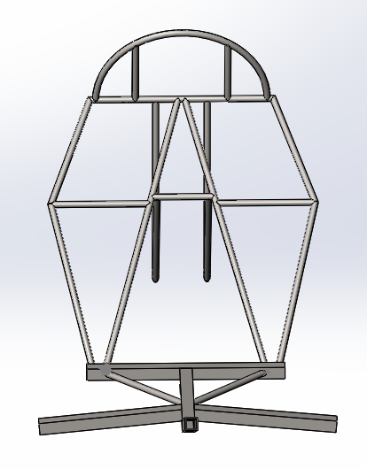
Figure 8: Frame Design – Front View
Among the metals in the market, steel and aluminum were the two best candidates for the Frame materials because of their availability and prices. Due to the limited budget, the team decided to use low-carbon steel for the Frame. Another reason is that low-carbon steel is easiest for the team members to fabricate using MIG welding. Team members are not experienced with welding and thus, aluminum could have been a challenge and require more time to practice. After researches are done on metal vendors, steel was available in more shapes, sizes, and prices and thus, reduced the challenges the design team had to overcome. Moreover, steel has a higher yield and ultimate strengths ensuring the rider will be protected in case of a rollover. [14]
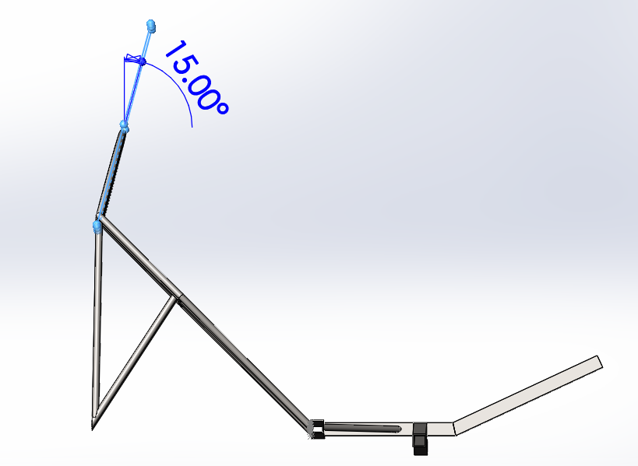
Figure 9: Frame Design – Side View
Using the ASME HPVC rule book 2021, the top load would be applied at 12 degrees angle to the vertical axis. Therefore, the Frame's top hoot was designed to be at 15 degrees angle to minimize the bending stress caused by the 2670N top load [15]. Also, 15 degrees angle is a sufficient number for members to measure and set up during the fabrication process. The hoot was designed to be 260mm to provide approximately 8.7 cm spacing between the rider’s head (assumed to be about 220 mm in diameter) and the ground when the vehicle upside down.
    - Simulation and Analysis
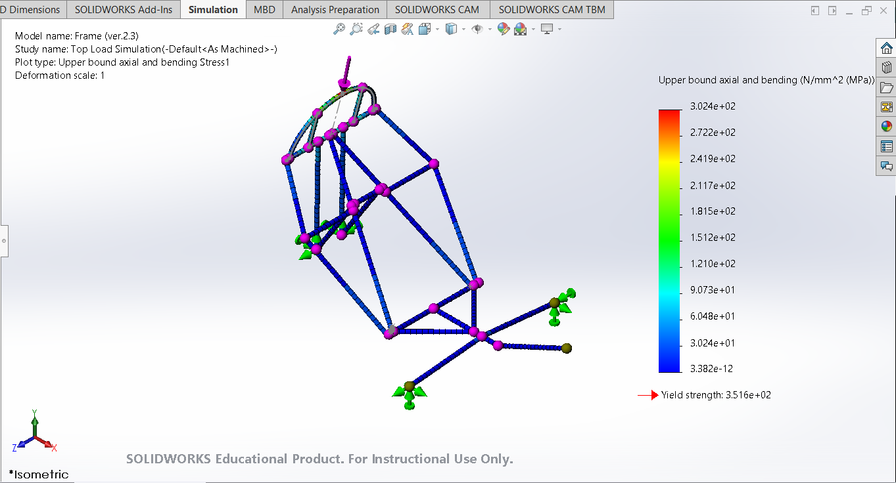
Figure 10: 2670N Top Load Simulation – Isometric View
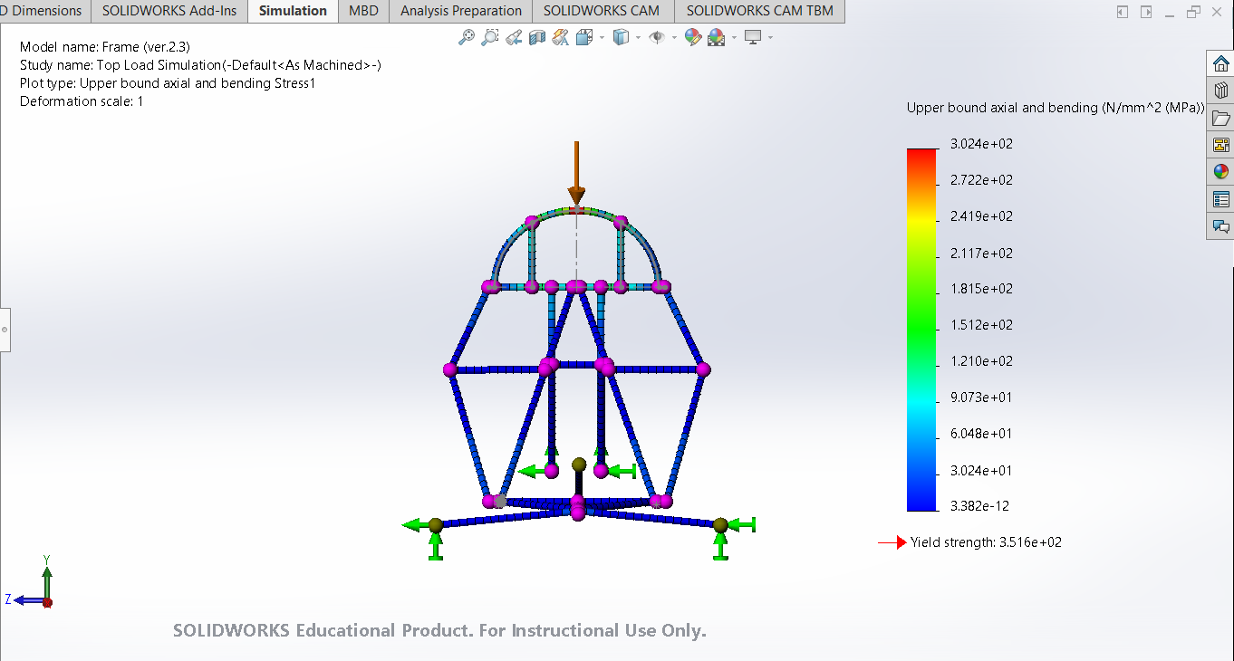
Figure 11: 2670N Top Load Simulation – Front View
A top load of 2670N was applied at the top and middle points of the hoot at 12 degrees angle. Four joints connecting two front wheels and one back wheel were fixed in all directions. The maximum stress of 304 MPa occurred at the same location that the force was applied. According to SolidWorks 2021, AISI 1020 steel has a yield strength of 351.57 MPa meaning the top load would give a 1.16 factor of safety for the red area shown in figure 11. The hoot contains two small steel bars welded straight up to provide more strength and distribute the load. Ideally, another steel bar could have been added in the middle of the Frame; however, it would be complicated for team members to weld it onto the Frame at the intersection of 3 bars (see figure 11). Since the red area is very small, team members decided 1.16 factor of safety would be sufficient. The other areas would have a factor of safety of 1.4 or more indicating the Frame could withstand the required load. Because the hood was designed to be at 15 degrees from vertical, the bending stress is about 100 MPa. Based on the simulations, low-carbon steel is expected to withstand the largest required force. However, team members were concerned that failure would not occur in the material but at the weldment points. Thus, the top hoot was designed to be supported by 4 weldments to distribute to the load more sufficiently.
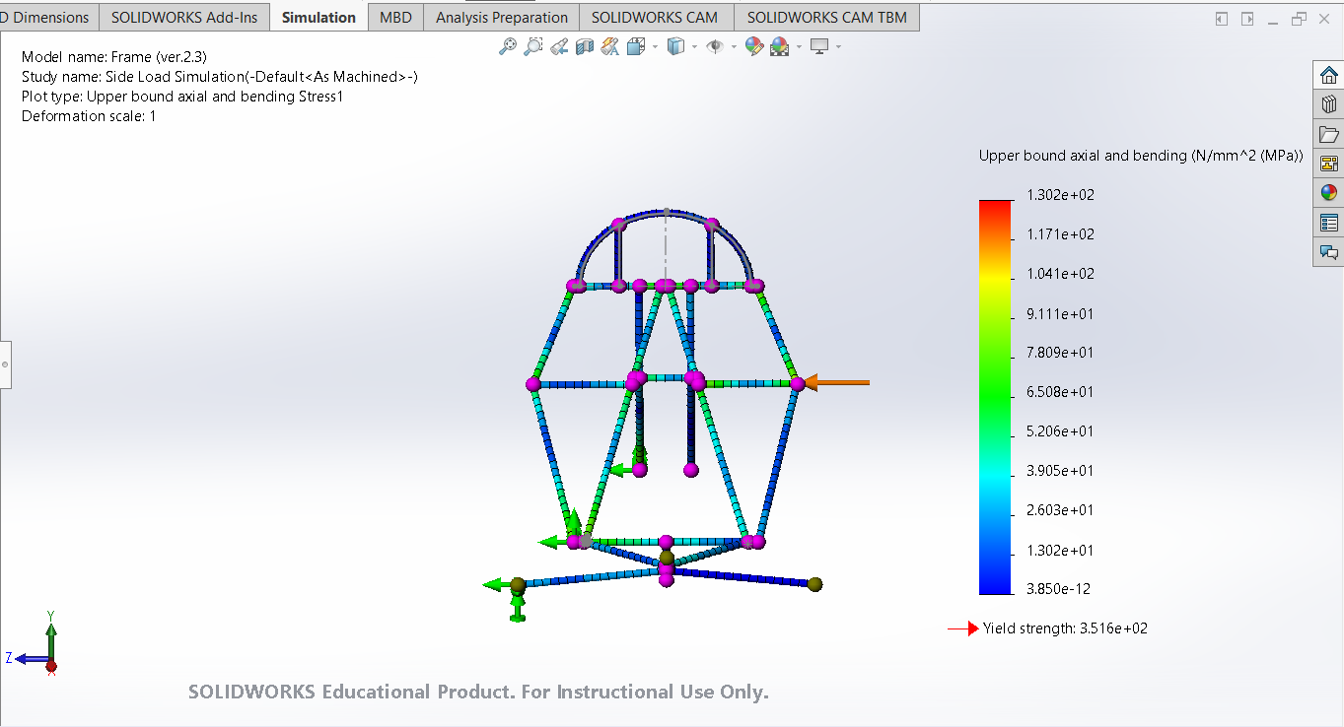
Figure 12: 1330N Side Load Simulation with 3 Fixtures – Front View
A side load of 1330N was applied at the shoulder height resulted in maximum stress of 130.2 MPa. This simulation was done with 3 fixtures as shown in figure 12. These fixtures were located at the points where the Frame was expected to contact the ground in the case of rolling over to one side. The 2.7 factor of safety confirmed the Frame would withstand the required sideload.3
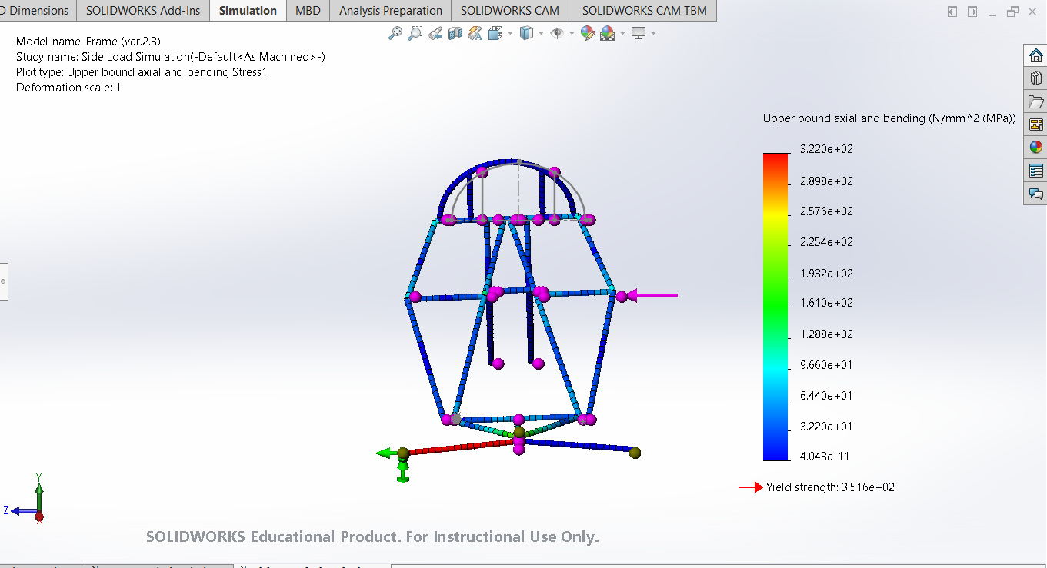
Figure 13: 1330N Side Load Simulation with 1 Fixture – Front View
Figure 13 also demonstrates a simulation of a 1330N side load at the shoulder height; however, this simulation was only fixed at one front wheel. The fixture was expected to be the first point where the Frame would contact the ground when it rolls over to one side. Thus, this simulation is a demonstration of the worst scenario where the Frame must withstand a force of 1330N for a very short time. As shown above, the maximum stress 322MPa occurred at the square hollow tube that connects the fixed front wheel and the rest of the Frame. The resulted 1.09 factor of safety is not ideal; however, this is only the worst scenario and it was assumed to last for a few seconds. The worst-case side load simulations provided a conclusion that the larger the diameter or the width of the tube, the smaller maximum stress would occur. Thus, it explained why team members used ½'' square tube for the base of the Frame.
    - Fabrication Process, Challenges, and Solutions
The fabrication process started at the end of September 2020; however, due to the pandemic, many restrictions caused delays in the fabrication process including the maximum amount of members that could be in the machine shop at a time and the opening hours of the GCU engineering shops. Also, time conflict was another major challenge for the team to build the Frame together. From September 2020 to the beginning of 2021, the team worked on finalizing the design drawings, purchasing, and cutting metals. Within the first months of 2021, the Frame fabrication is 90% completed as shown in figure 14.
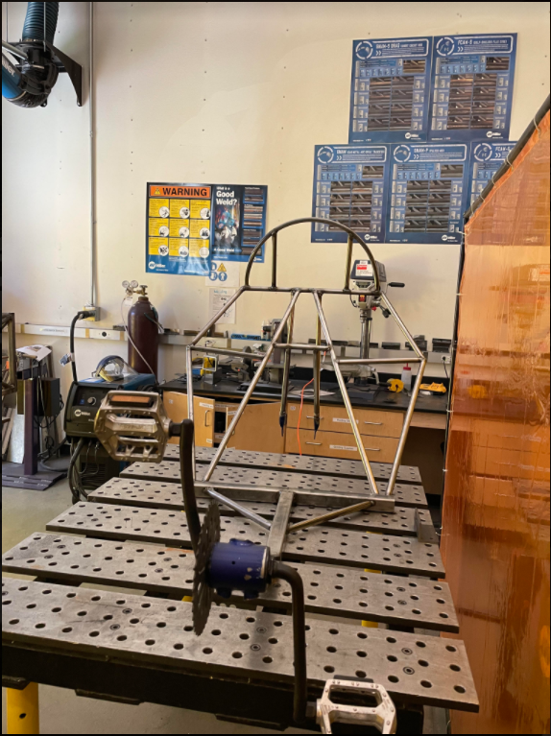
Figure 14: Frame Fabrication
Overall, the fabricated Frame was built close to the designed specifications. The only difference is the two steel tubes at the shoulder heights are not horizontal as in the design (see figure 14). This issue occurred when one of the steel tubes was cut shorter than needed and there was not enough material to recut another tube. Thus, the steel tube on the other side was also sized down for both tubes to be symmetrical. Symmetry is important to ensure the performance consistency of the Frame. Though the tubes are not at the designed orientations, their main purposes are to connect the overall protection system and provided more support on the load. Since the sideload simulation gave a 2.7 factor of safety, giving room for the team to have minor fabrication offsets. Actual tests shall be performed to evaluate the actual performance of the vehicle as a whole.
The biggest challenge for the ASME GCU club was to raise a minimum of $1500 to build the vehicle. The budget has been extremely limited and thus, purchasing all vehicle parts is not an option. During the fabrication process, the team was able to connect with GCU Police Officer who was willing to donate old bicycles for the club to reuse the parts on the GCU tricycle. Fortunately, the team was able to obtain a small bike with a steel frame and a simple system crankset. A 26'' wheel and other drivetrain parts were also collected from old and unused bicycles at GCU.
  - Drivetrain
This section discusses all the different components of the drivetrain of the recumbent bike as well as the different variations of each component. The Drivetrain Subsystem decided to implement an 8-speed cassette system with a single chainring and grip shifter. Other components used to transfer power such as the chain and crankset have no major variations, and therefore will not be discussed in detail. There are several components to the recumbent trike’s drivetrain: the cassette, rear derailleur, chain with chain routers, crankset, and gear shifters. Some of these parts come in different variations, and the variations that were chosen are discussed below.
    - Chainring
On all bicycles and tricycles, there is a cog attached to the pedals that allow the motion of the rider's pedaling to power another cog or cog set that is attached to the axle of the driving wheel; this is how the entire vehicle moves forward. The cog attached to the pedals is called a chainring. In some drivetrains, there are multiple chainrings to allow for a wider range of gear ratios and speeds. The number of teeth on the chainring may differ as well; they typically range anywhere from about 22 teeth to 50 or more teeth.
The single chainring system was chosen to simplify the assembly and use of the drivetrain as well as reduce costs. Drivetrains that implement more than one chainring may have a wider range of gear ratios but also create more issues that outweigh the benefits of achieving more speeds. Firstly, multiple chainring systems are ultimately more complicated to put together due to the requirement of a front derailleur. A front derailleur is a component that allows the rider to shift the chain to the different chainrings and achieve different speeds. It would require significantly more time and effort to not only implement and perfectly adjust this multiple chainring system with the front derailleur but also have new riders feel comfortable with controlling this component on top of all the other components of the drivetrain and other subsystems. The requirement of a front derailleur would also add to the cost of the trike’s extremely limited budget. This gives even less leeway for all the subsystems to purchase other expensive but necessary components. The Drivetrain subsystem sought to prioritize simplicity and cost efficiency, hence why the single chainring system with no front derailleur was chosen.
    - Cassette
On most bicycles/tricycles, there is a collection of cogs attached to the same axle as the driving wheel. There are two types of cog-sets: a freewheel vs. a cassette. There are many differences between the two but only two of the main disparities will be discussed. Firstly, the cogs on a freewheel are permanently fixed together as one unit that is directly screwed onto the hub of the wheel. On a cassette, the cogs are not permanently fixed together; they all lie on the freehub body attached to the wheel and are held together by a nut or lock ring that locks onto the outermost cog. Secondly, different hubs are compatible with each cogset. The freewheel system was created before the cassette, and the hub that goes with the freewheel typically has its bearing placed closer together, which did not improve axle strength. In contrast, the invention of the cassette, as well as its corresponding freehub body with bearings, placed further apart brought significant improvements to the strength of the wheel and hub axle. Ultimately, the cassette system was chosen for its flexibility in gear ratios seen in how the cogs are not permanently fixed together as well as the ability to prevent the axle from deforming as easily.
    - Shifter and Other Components
Two different kinds of shifters can be used to move the chain onto different cogs to achieve different gear ratios: the grip shifter and the trigger shifter. The grip shifter allows the rider to twist a handle that then twists and changes the tension of the cable that runs down to the derailleur that moves the chain to different cogs. In contrast, the trigger shifter utilizes levers that can be squeezed and released to change the tension of the cable. The Drivetrain subsystem decided to go with the grip shifter because this component was donated and allowed for the subsystem to cut costs. There is also no significant advantage between one or the other; these shifters are typically chosen with personal preference. Other components that are necessary for the completion of the drivetrain such as the chain and the crankset, which consists of the chainring, crank arms, and pedals, are generally identical in all bicycles and tricycles, therefore there were no different variations to consider. The cassette and chainring that came with the crankset used in this trike were also donated, so the number of teeth on these cogs was not considered in depth. An 8-speed cassette was donated which allows the trike to achieve similar speeds to that of a regular bike.
  - Finance
    - Funding Resources
Funding was collected from a variety of sources. Most of the funds collected came from ASGCU, our university's student government whom we collaborate and corporate to come up with a total amount our club may receive for the project. Other funding sources came in the form of bake sales, donated and discounted proceed on some items.

    - Finance Management
Managing the finances of this project consisted of bookkeeping and spreadsheets. Keeping finances is vital to a project. To keep track of the funding coming in, going out, who the club purchases from, what kind of funds were used, and when these purchases were made. This is all to make financial decisions, list properties, and provide efficient productivity.
Table 1: Example of the Financial Spreadsheets
DATE | BUYER | BUYER LOCATION | FUND TYPE | AMOUNT | DATE ARRIVED
2/1/21 | ASME | Utah Trikes | ASME | $230 | 2/24/20
11/30/20 | ASGCU Advocate | Sunbrella & other fabric | ASGCU App. | $151.27 | 12/15/20
11/18/20 | ASGCU Advocate | Industrial metal Supply  (Steel and Aluminum Tube) | ASGCU App. | $151.27 | 11/28/20

    - Challenges and Solutions
There were challenges in finding sources of funding during a global pandemic. One main issue for all bike shops located in our area was that they were experiencing global bike component shortages. Donating money and or reduced prices was not possible. However, one must adapt. The best solution was to look to the nearest sources. Friends, family, and our university's student body to donate funds. Amidst working apart from one another, it became ever more apparent to work closer together.

[1] W. Beauchamp, How to Build a Streamliner: Construction Techniques and Materials, Recumbents, Dec. 26, 2003. Accessed on: Feb. 12, 2021. [Online]. Available: http://www.recumbents.com/wisil/Plans/how_to_build_a_streamliner2.htm
[2] R. Wianecki, Rick Wianecki Builds the Frank-n-Liner, Recumbents, 2007. Accessed on: Feb. 12, 2021. [Online]. Available: http://www.recumbents.com/wisil/wianecki/frank-n-liner/frank-n-liner2.htm
[3] W. Beauchamp, How to Build a Streamliner: Overview, Recumbents, Dec. 17, 2003. Accessed on: Feb. 12, 2021. [Online]. Available: http://www.recumbents.com/wisil/Plans/how_to_build_a_streamliner.htm
[4] Engineering Toolbox, U.S. Standard Atmosphere, Engineering Toolbox, 2003. Accessed on: Feb. 12, 2021. [Online]. Available: https://www.engineeringtoolbox.com/standard-atmosphere-d_604.html
[5] National Aeronautics and Space Administration, The Drag Equation, National Aeronautics, and Space Administration, 2003. Accessed on: Feb. 13, 2021. [Online]. Available: https://www.grc.nasa.gov/www/k-12/airplane/drageq.html#:~:text=The%20drag%20equation%20states%20that,times%20the%20reference%20area%20A.&text=For%20given%20air%20conditions%2C%20shape,for%20Cd%20to%20determine%20drag
[6] Recumbents, 2021. Accessed on: Feb. 10, 2021. [Online]. Available: http://www.recumbents.com/home/
[7] Sailrite, 2021. Accessed on: Jan. 15, 2021. [Online]. Available: https://www.sailrite.com/
[8] Fabric, 2021. Accessed on: Jan. 14, 2021. [Online], Available: https://www.fabric.com/
[9] “How Much Does the Average Man Weigh?,” Healthline, Aug. 23, 2017. https://www.healthline.com/health/mens-health/average-weight-for-men#_noHeaderPrefixedContent.
[10] “Average Height by State 2021,” worldpopulationreview.com. https://worldpopulationreview.com/state-rankings/average-height-by-state.
[11] “Average Height of American Women,” WorldAtlas, 2021. https://www.worldatlas.com/articles/what-is-the-average-height-of-american-women.html#:~:text=What%20is%20the%20Average%20Height%20of%20American%20Women? (accessed Feb. 13, 2021).
[12] “Average Weight for Women Worldwide (Stats Inside),” MedicineNet, Nov. 19, 2019. https://www.medicinenet.com/weight_women/article.htm#:~:text=Average%20Weight%20for%20Women%20in%20the%20U.S.%20In (accessed Feb. 13, 2021).
[13] “Human power,” Wikipedia, Feb. 10, 2021. https://en.wikipedia.org/wiki/Human_power#:~:text=Normal%20human%20metabolism%20produces%20heat%20at%20a%20basal (accessed Feb. 13, 2021).
[14] AmesWeb, Young’s Modulus of Steel, 2021. Accessed on: Mar. 3, 2021. [Online]. Available: https://amesweb.info/Materials/Youngs-Modulus-of-Steel.aspx
[15] ASME Human Powered Vehicle Challenge, Rules for the 2021 Human Powered Vehicle Challenge Competitions, 2021. Accessed on: Mar. 3, 2021. [Online]. Available: HPVC_2021_Rules_9-23-2020.pdf

